



W1562N, the renewal machine of W1500 is introduced
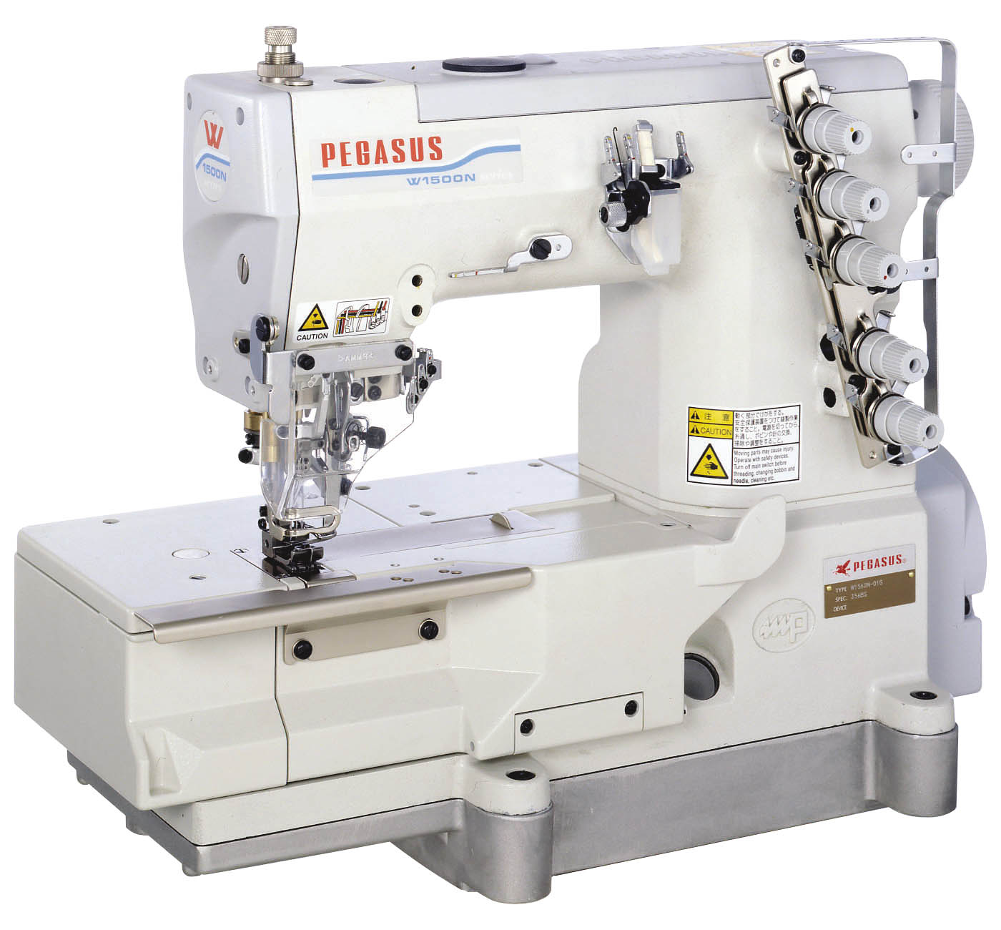

This further developed economical - high - speed machine is capable of a speed of up to 6000 rpm and ensures high productivity. W1562N - series offers basically almost the same features like W1562 - series with additional and outstanding new technical points:

- A tight seam and soft seam are both easily achieveable with the same machine by changing only the position of the cam installation

- A additional adjustment to the sewing condition is possible.

- Improved ease of operation & maintenance
  - upper metal handwheel
  - new side cover
  - fine adjustment screw on upper looper holder
  - colour marked thread guides for easy and simple threading
  - tilt adjustment of presser foot sole
We will explain in more detail:

    - A tight seam and a soft seam are achieved by one machine, by only changing the cam installation direction (upper and lower) and the appearance and elasticity of the stitch changes.

Tight stitch NEW

W1562N-○○○x□□□ □S – type.
standard factory set up position

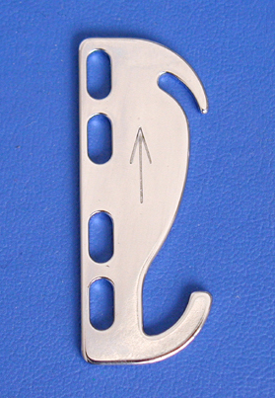
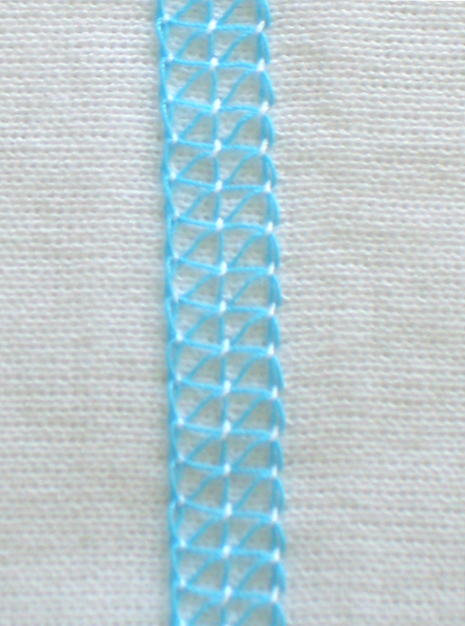
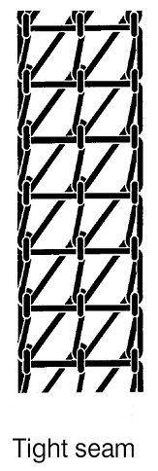

Tight stitch such as a W500,
W600- Series
>>> Mainly the thread tightening is applied when the needle is in the top position

Soft Stitch

W1562N-○○○x□□□ □T – type, standard factory set up position
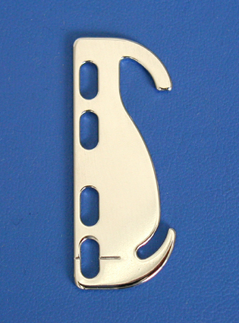
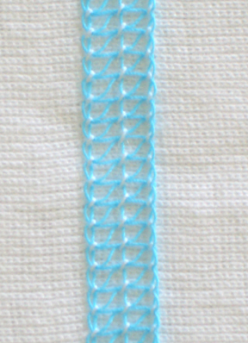
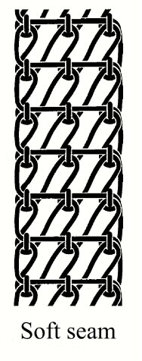

Soft stitch such as a W1500 Series
>>>Mainly the thread tightening is applied when the needle is in the low position

    - The adjustment to the sewing condition is possible.
It is possible to correspond to a wide sewing condition by adopting the needle thread spring.

When it is necessary to make the needle thread loop small as required by cotton thread etc., it is possible to adjust easily. NEW
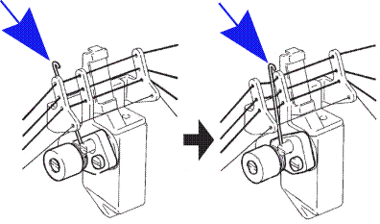
(1) (2)

- The needle thread spring is set not to work (factory set up).

(2) The slackness of the needle thread is absorbed by working needle thread take-up spring, and the needle thread loop will become small (cotton thread used).

CAUTIONS !!
In case the "needle thread pressure spring" is effective, except for "thread which makes bigger needle thread loop" such as cotton thread, skipp stitches can easy happen.

    - Improved ease of operation & maintenance

1, Hand wheel on upper shaft
NEW
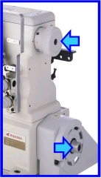
Hand wheel is fully enclosed like on W2600, avoiding any winding of threads round the shaft

Adapter for the needle positioner is on bottom shaft

2, Movable side cover NEW

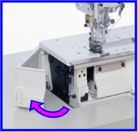
Side cover opens and closes for adjustment of the differential lever

3, Micro adjustment of looper
NEW
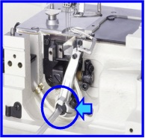
The looper front-to rear adjustment is by micro adjustment

4, Colour coded thread guides
NEW
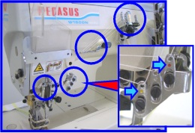

By marking the thread guides with a colour code, each thread has it’s own colour, to prevent wrong threading by the operator.

5, Changed thread guide
NEW

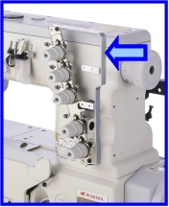

The thread guide was changed to avoid any entangling of threads and to avoid threads getting cought by the hand wheel.

6, Presser foot tilt
NEW
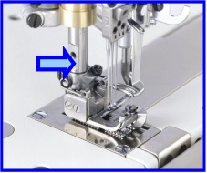

New presser foot with adjustment screw for the presser foot tilt to achieve better climbing function.

Suitable table top for W1562N

As the hand wheel is fitted to the top shaft the pulley on the bottom shaft is more or less the same as from W562. Therefore it is possible to use the table top of W562 for W1562N.

Exeption:
In case of fully submerged installation, the table top is like W1562 as the front cover of the machine bed is different
(stepped and not straight like W562).

Needle positioner:
In case a needle positioner has to be used, it can be fitted to the pulley. The adoption for the needle positioner is combined with the pulley.

W1562N - Common Specifications

Subclasses: -01（Multi use for -03, -08）
-02 and -05
Max. speed: 6,000 rpm * The maximum speed is different depending on the subclass and the sewing condition
(with FT0B ~ 5500 rpm)
Pressure foot lift: 6.3 mm (-01 / -02) ・ 5.3 mm (-05)
Number of Needles and Needle distance:
2-needle (3.2 mm/ 4 mm/ 4.8 mm *）
3-needle (5.6 mm / 6.4 mm)
Standard needle: UY128GAS
Presser foot: Tilt type pressure foot which sews smoothly over the cross seam is adopted. * Only for -01 type

Feed type: Differential bottom feed
Stitch length: 1.2 ～ 4.4 mm
Differential ratio: 1：0.5 ～ 1：1.3
Standard stitch length:11～14 stitches / inch (BS, BT needle plate）
Less than 10 stitches / inch （CT needle plate)
Stitch length adjustment: Push button type
Diff. feed amount adjustment: Intermittent type (without microadjust)
Adjustment of looper front rear: With micro adjustment screw
Devices : UT / FT / MD / TK

Available Subclasses:

1, Multi use machines
Plain seaming –01G, including
covering –03 and hemming –08

W1562N-01Gx240BS
W1562N-01Gx348BS/Y1548
W1562N-01Gx356BS
W1562N-01Gx364BS
= standard (PE stock)
-01G (J) = Plain seaming –01G
including guides for covering -03
and guides for hemming -08
optional:
W1562N-01Gx232BT
W1562N-01Gx240BT
W1562N-01Gx364CT
Thread cutter UT = like W1562
UT1B = solenoid driven UT
UT3J = pneumatic driven UT
(with air blower)
UT4C = pneumatic driven under bed
and top cover thread trimmer
W1562-01Jx356BS or CT
-01Jx356 has small feeders like
W1562-01Gx240

2, Binding machines

W1562N-02Gx232BS
W1562N-02Gx240BS
W1562N-02Gx248BS
W1562N-02Gx356BS
W1562N-02Gx364BS
tape cutter TK: same like W1562
TK1B = solenoid driven TK
TK3C = pneumatic driven TK

Remark: All binding machines
are delivered without binder

3, Lace attaching machines

W1562N-05Bx232BS/FT0B/MD0A
W1562N-05Bx232BS/FT0B/Y1840
W1562N-05Bx240BS/FT0B/MD0A
W1562N-05Bx356BS/FT0B/MD0A
W1562N-05Bx364BS/FT0B/MD0A
= for future stock
at present is W1562-05 still
without “N” available
optional:
W1562N-05Bx232BT/FT0B/MD0A
W1562N-05Bx240BT/FT0B/MD0A
W1562N-05Bx356CT/FT0B/MD0A
W1562N-05Bx364CT/FT0B/MD0A
tape cutter TK: same like W1562
TK1B = solenoid driven TK
TK3C = pneumatic driven TK
The new gauge parts catalogue of W1562N is available for download in the section PE-News.

You also can download the PE-News as PDF – file and as original Word document for your translation, to make it available for your sales and technical staff in your native language.

Ullrich Rabe, PE

